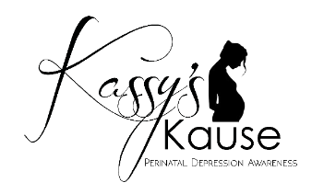
Postpartum Support International Scholarship Application
Deadline to submit application: February 20th, 2022.

Kassy’s Kause is now accepting applications for scholarships to be used towards the registration of the Postpartum Support International training March 9-11, 2022 in Albuquerque, New Mexico. Multiple scholarships will be awarded. Please complete the following information and email to kassykausepresident@gmail.com no later than February 20, 2022. Thank you!

First/Last name: | Email: | Company/organization:  Position:
Mailing address:  City:  State: Zip: | Phone  ( ) | How did you hear about this scholarship?
Please circle all that apply:  Parent  Grandparent  Student  Counselor  Therapist (specialty):  _________________ | Social Worker  Home Visitor  Parent Educator  Medical Professional  Nurse  Doctor  Other: | Can you share your experience, if any, with Maternal Mental health?
Please tell us how you can use the information from the training: |  | Have you or someone you know experienced prenatal or postpartum depression? If yes, please share what you feel comfortable sharing. Please do not mention names.
Official use only:
Amount Awarded: | Date Received: | Board member(s):

